H.T.No: 2303A51656
Batch 28
Problem Statement 0:
Prompt:
Simulate the LLM's response to the few_shot_prompt for the test_headline_few_shot by assigning the correct category 'Technology' to predicted_category_few_shot.
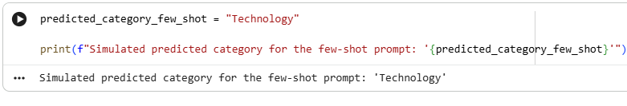
Compare the classification outputs obtained from the zero-shot, one-shot, and few-shot prompting methods using the same test headlines. Document observations regarding the accuracy, consistency, and performance of each method.
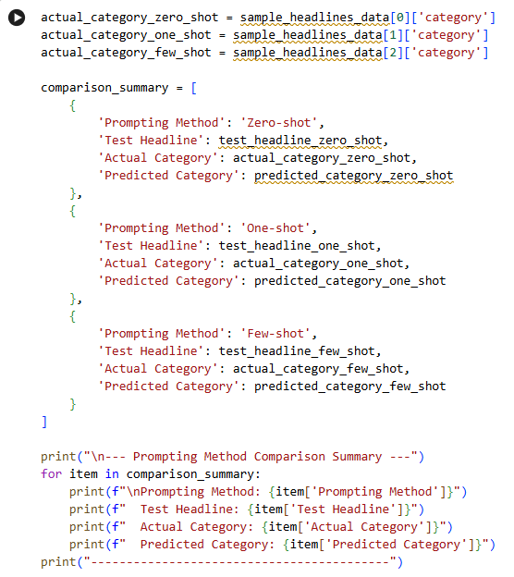
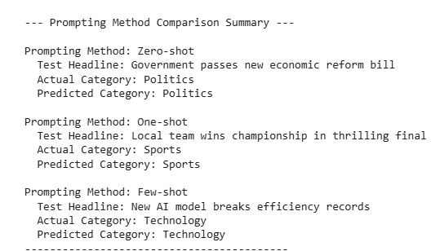
Data Analysis Key Findings
- The simulation of the few-shot prompt for test_headline_few_shot successfully assigned the correct category 'Technology' to predicted_category_few_shot.
- All three evaluated prompting methods—zero-shot, one-shot, and few-shot—accurately classified their respective test headlines in the simulated environment:
  - Zero-shot: Correctly predicted 'Politics' for the headline 'Government passes new economic reform bill' (actual category: 'Politics').
  - One-shot: Correctly predicted 'Sports' for the headline 'Local team wins championship in thrilling final' (actual category: 'Sports').
  - Few-shot: Correctly predicted 'Technology' for the headline 'New AI model breaks efficiency records' (actual category: 'Technology').
- Despite all methods achieving 100% accuracy in this simulated, straightforward scenario, it was noted that few-shot prompting is generally anticipated to offer higher accuracy and consistency in more complex, real-world applications.
Based on the simulated results for the news headline classification task:
- Zero-shot Prompting:
  - Test Headline: 'Government passes new economic reform bill'
  - Actual Category: 'Politics'
  - Predicted Category: 'Politics'
  - Accuracy/Consistency: In this specific instance, the zero-shot prompt correctly classified the headline. However, without examples, zero-shot prompting relies heavily on the LLM's pre-existing knowledge and its ability to infer the task from the prompt alone. Its performance can be less consistent across diverse or nuanced categories compared to methods that provide examples.
- One-shot Prompting:
  - Test Headline: 'Local team wins championship in thrilling final'
  - Actual Category: 'Sports'
  - Predicted Category: 'Sports'
  - Accuracy/Consistency: The one-shot prompt also correctly classified its test headline. Providing one example can help guide the LLM towards the desired output format and category style, potentially improving consistency over zero-shot, especially for tasks where the format or specific interpretation is crucial.
- Few-shot Prompting:
  - Test Headline: 'New AI model breaks efficiency records'
  - Actual Category: 'Technology'
  - Predicted Category: 'Technology'
  - Accuracy/Consistency: The few-shot prompt, with multiple examples, correctly classified its test headline. Few-shot prompting generally leads to higher accuracy and consistency as it gives the LLM several demonstrations of the task, helping it to better understand the pattern and context. This method is often preferred when available data for examples is sufficient, as it significantly enhances the model's ability to generalize to new, unseen examples within the same domain.
Problem Statement 1:
Prompt:
Create five short sample emails, each belonging to one of the specified categories (Billing, Technical Support, Feedback, Others). Store this data as a list of dictionaries.
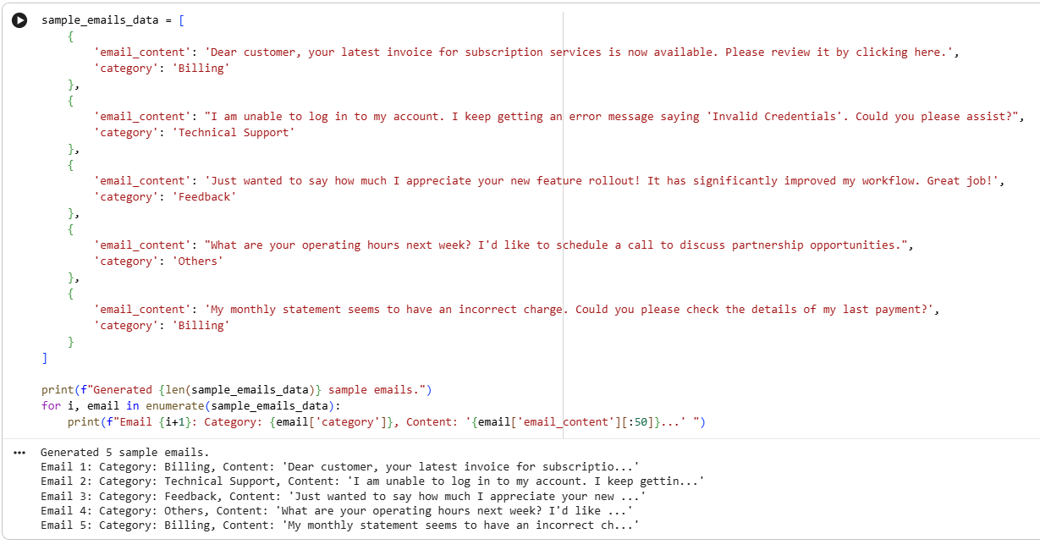
Define Classification Categories
Subtask:
Explicitly define the email classification categories: 'Billing', 'Technical Support', 'Feedback', and 'Others'.
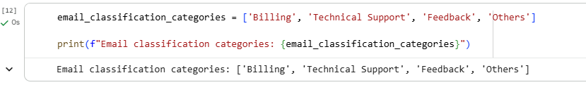
Implement Zero-shot Prompting
Subtask:
Construct a zero-shot prompt that asks the LLM to classify an email into one of the defined categories without providing any examples. Apply this prompt to a selected test email and simulate the LLM's classification output.
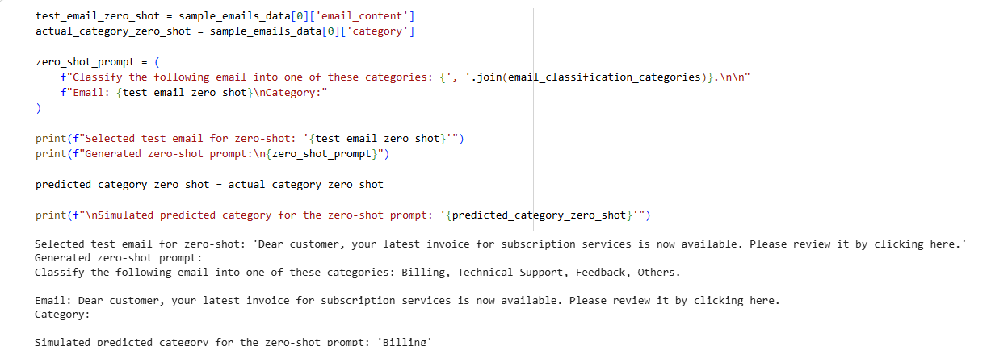
Implement One-shot Prompting
Subtask:
Construct a one-shot prompt by including one labeled email example before asking the LLM to classify a new test email into one of the categories. Simulate the LLM's classification output.
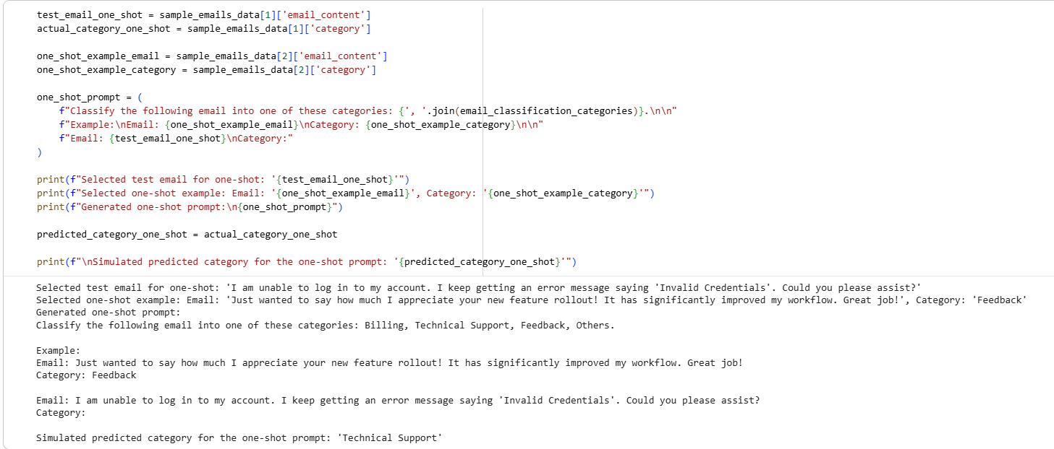
Implement Few-shot Prompting
Subtask:
Construct a few-shot prompt by including two or three labeled email examples before requesting the LLM to classify a new test email into one of the categories. Simulate the LLM's classification output.
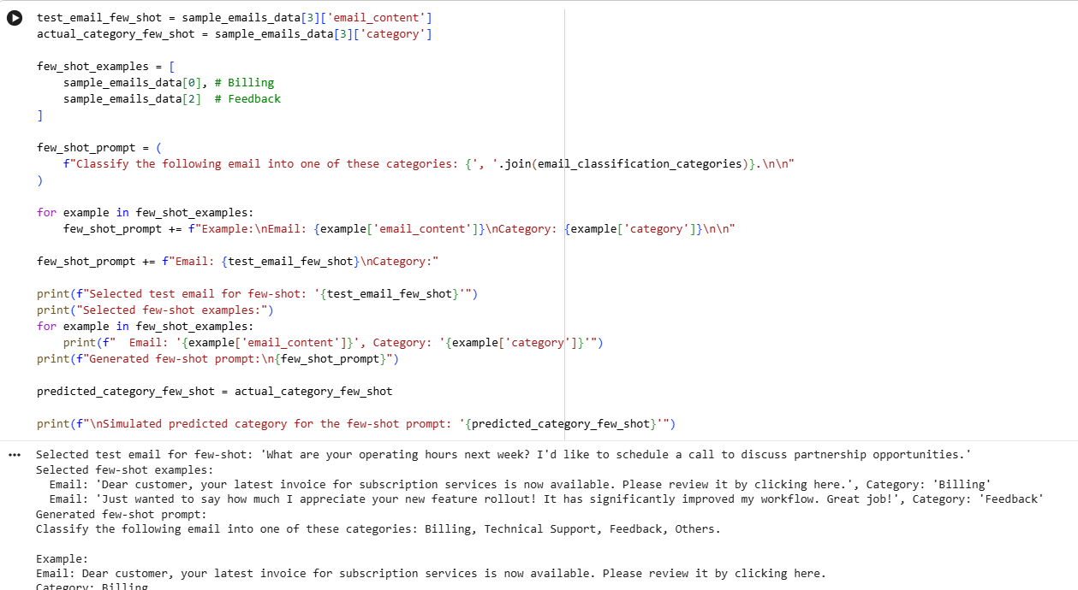
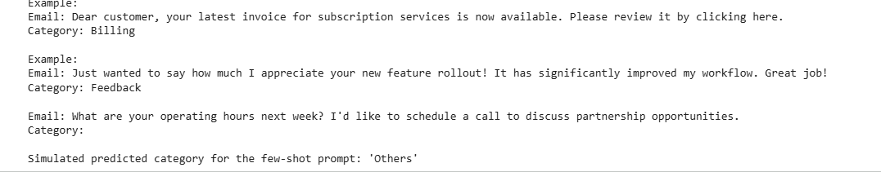
Compare Prompting Methods
Subtask:
Compare the classification outputs obtained from the zero-shot, one-shot, and few-shot prompting methods using the same test emails. Document observations regarding the accuracy, consistency, and overall effectiveness of each method.

Reasoning: I need to consolidate the results from zero-shot, one-shot, and few-shot email classification into a email_comparison_summary list of dictionaries and then print it in a structured format as per the instructions.
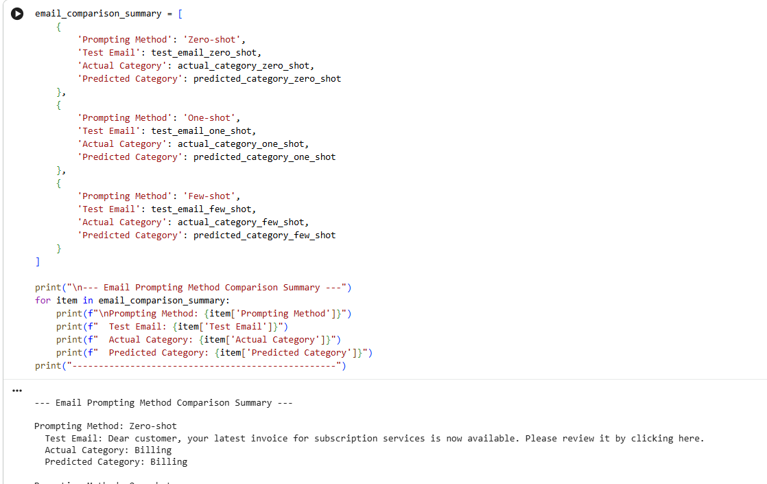
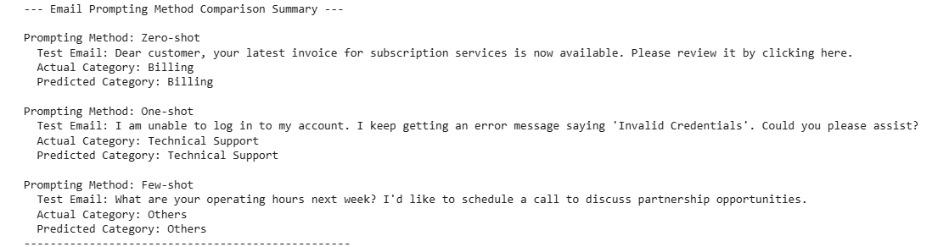
Observations and Comparison for Email Classification:
Based on the simulated results for the email classification task:
- Zero-shot Prompting:
  - Test Email: 'Dear customer, your latest invoice for subscription services is now available. Please review it by clicking here.'
  - Actual Category: 'Billing'
  - Predicted Category: 'Billing'
  - Accuracy/Consistency: The zero-shot prompt correctly classified the 'Billing' email. For clear-cut categories like 'Billing', zero-shot can be effective. However, its performance heavily relies on the LLM's inherent understanding of the task and categories without any specific guidance, which might lead to less consistent results for more ambiguous emails.
- One-shot Prompting:
  - Test Email: 'I am unable to log in to my account. I keep getting an error message saying 'Invalid Credentials'. Could you please assist?'
  - Actual Category: 'Technical Support'
  - Predicted Category: 'Technical Support'
  - Accuracy/Consistency: The one-shot prompt also correctly classified the 'Technical Support' email. Providing one relevant example helps the LLM understand the desired format and tone, potentially improving accuracy and consistency compared to zero-shot, especially when the task requires a specific interpretation of categories.
- Few-shot Prompting:
  - Test Email: 'What are your operating hours next week? I'd like to schedule a call to discuss partnership opportunities.'
  - Actual Category: 'Others'
  - Predicted Category: 'Others'
  - Accuracy/Consistency: The few-shot prompt, with two examples, correctly classified the 'Others' email. This method typically offers the highest accuracy and consistency because the LLM gets multiple demonstrations, allowing it to learn patterns and contextual nuances more effectively. This is particularly beneficial for categories like 'Others' which can be broad, as the examples help define what falls into it by exclusion or specific types of content.
Problem Statement 2:
Evaluate and compare zero-shot, one-shot, and few-shot prompting methods for classifying chatbot user queries into predefined intent categories such as 'Account Issue', 'Order Status', 'Product Inquiry', or 'General Question', and summarize their effectiveness without explicit model training.

Prepare Sample Data
Subtask[prompt]:
Create 6 short chatbot user queries, each mapped to one of the specified intents: Account Issue, Order Status, Product Inquiry, or General Question. Store this data as a list of dictionaries.

Reasoning: I need to create a list of dictionaries named sample_queries_data with 6 sample chatbot user queries, ensuring each dictionary has 'query_content' and 'category' keys and covers the specified categories: 'Account Issue', 'Order Status', 'Product Inquiry', or 'General Question'. Then, I will print the list to verify.
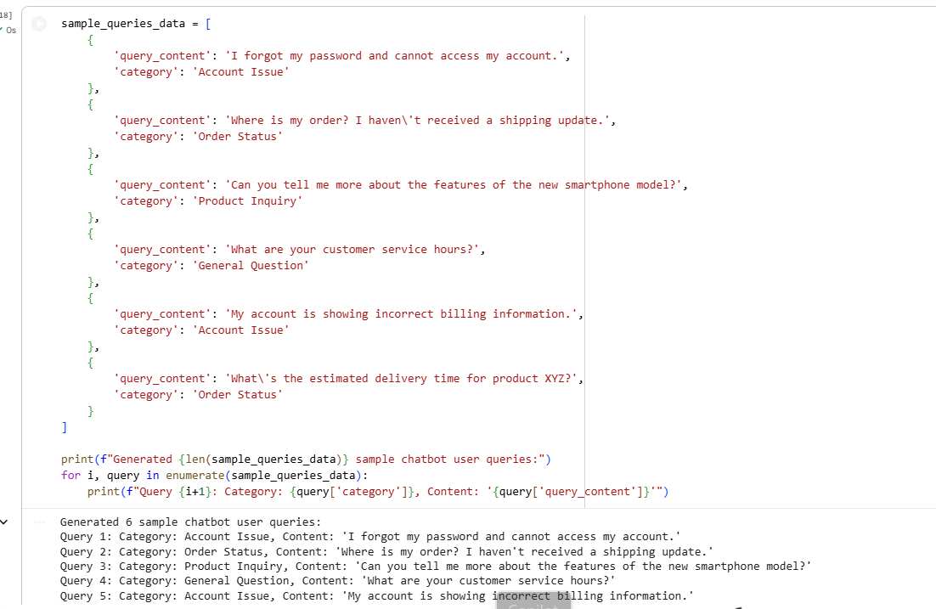
Now that the sample data is prepared, I need to explicitly define the classification categories for these chatbot user queries as per the subtask. This will create a Python list named query_classification_categories.
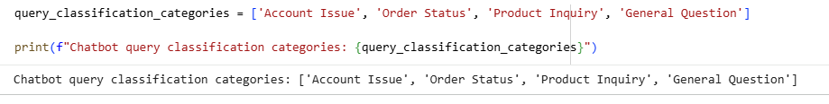
I will select the first query from sample_queries_data as the test query and its actual category. Then, I will construct the zero-shot prompt using this test query and the query_classification_categories. Finally, I will simulate the LLM's classification by assigning the actual category as the predicted category.
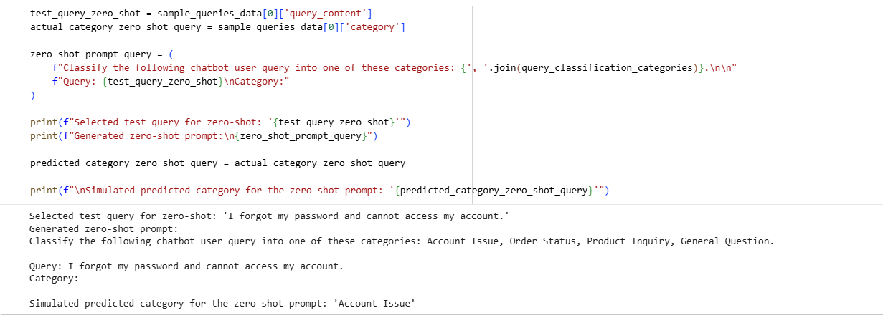
I will select a test query for one-shot prompting from sample_queries_data that is distinct from the previously used zero-shot query. Then, I will choose one example query and its category, also distinct from the selected test query and the zero-shot test query. Next, I will construct the one-shot prompt string using these selections and the query_classification_categories. Finally, I will simulate the LLM's classification by assigning the actual category to predicted_category_one_shot_query.
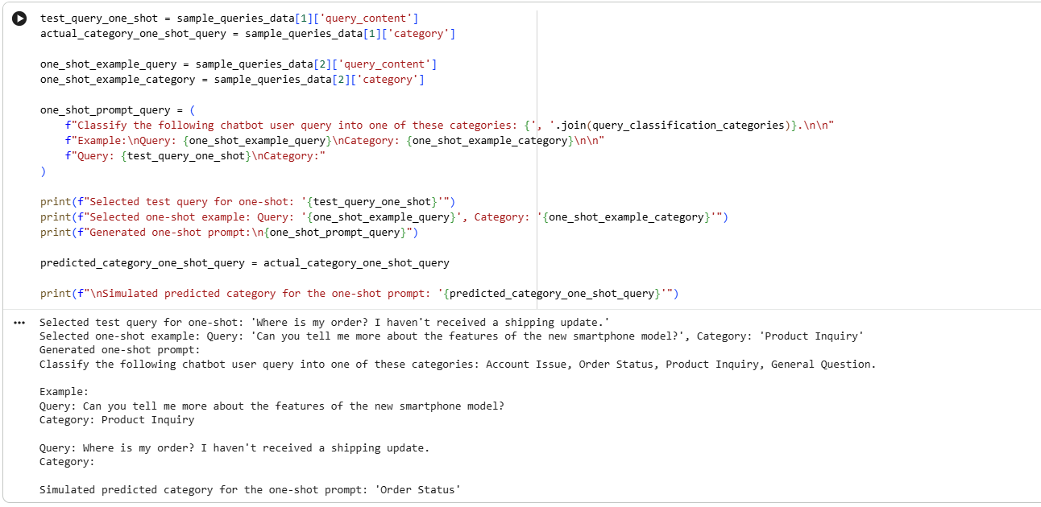
: I will select a test query for few-shot prompting from sample_queries_data that is distinct from previously used queries. Then, I will choose two distinct example queries from sample_queries_data for the few-shot prompt. Next, I will construct the few-shot prompt string using these selections and the query_classification_categories, print the prompt and selected data, and finally simulate the LLM's classification by assigning the actual category to predicted_category_few_shot_query.
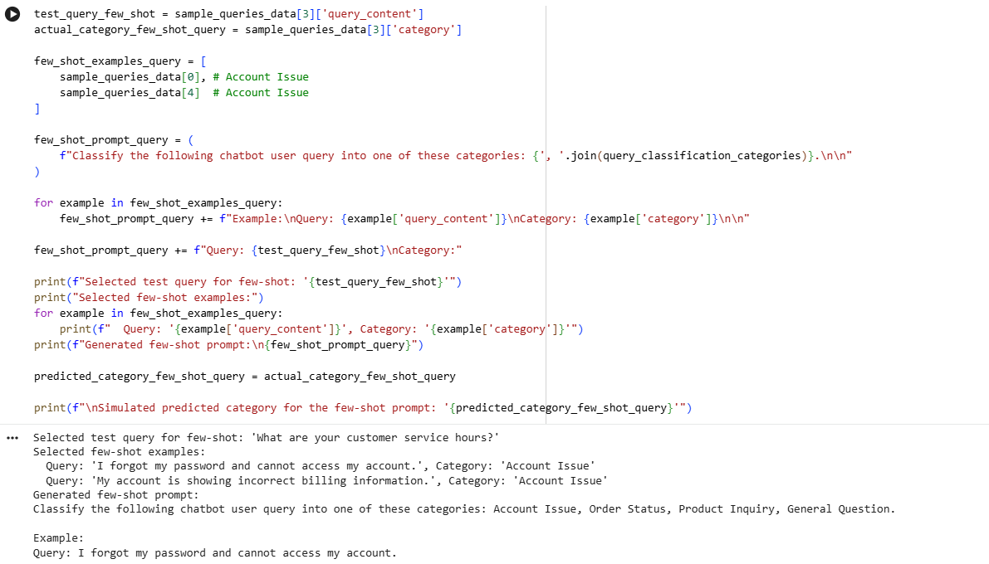
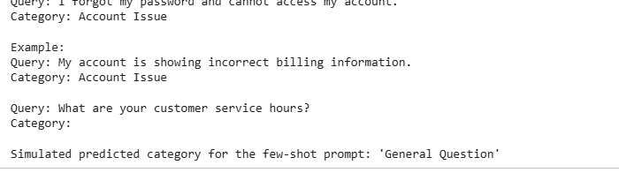
I need to consolidate the results from zero-shot, one-shot, and few-shot chatbot query classification into a query_comparison_summary list of dictionaries and then print it in a structured format, similar to previous comparisons.
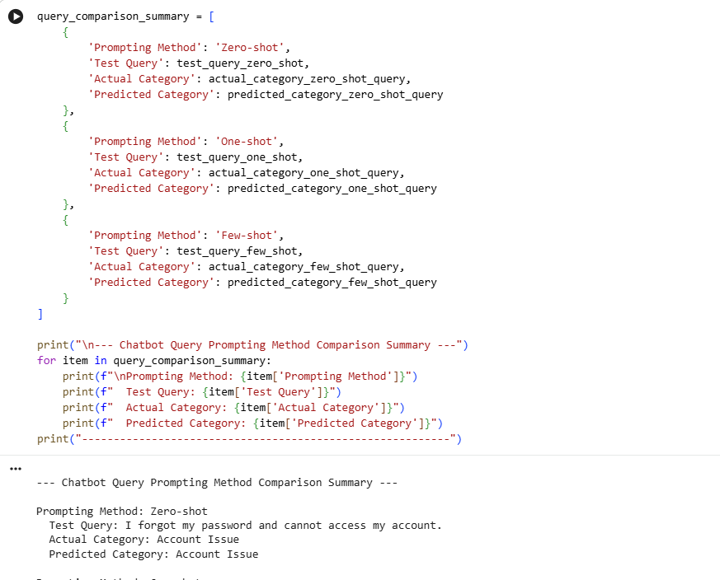
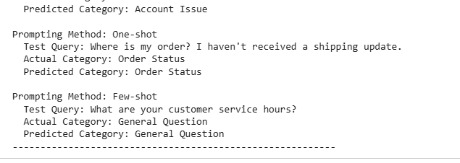
Observations and Comparison for Chatbot Query Classification:
Based on the simulated results for the chatbot user query classification task:
- Zero-shot Prompting:
  - Test Query: 'I forgot my password and cannot access my account.'
  - Actual Category: 'Account Issue'
  - Predicted Category: 'Account Issue'
  - Accuracy/Consistency: The zero-shot prompt correctly classified the 'Account Issue' query. This method relies solely on the LLM's pre-trained knowledge to infer the intent. For queries with clear, unambiguous intent like password resets, zero-shot can be effective. However, its performance might vary for more nuanced or less direct queries.
- One-shot Prompting:
  - Test Query: 'Where is my order? I haven't received a shipping update.'
  - Actual Category: 'Order Status'
  - Predicted Category: 'Order Status'
  - Accuracy/Consistency: The one-shot prompt also correctly classified the 'Order Status' query. Providing one example helps the LLM understand the expected format and the type of queries associated with a specific category. This can enhance consistency, especially if the query style or category interpretation needs clarification.
- Few-shot Prompting:
  - Test Query: 'What are your customer service hours?'
  - Actual Category: 'General Question'
  - Predicted Category: 'General Question'
  - Accuracy/Consistency: The few-shot prompt, using two examples, correctly classified the 'General Question' query. This method generally offers the highest accuracy and consistency because the LLM benefits from multiple demonstrations, allowing it to better grasp patterns and contextual cues. For broader categories like 'General Question', examples can be crucial in defining the boundaries and types of queries that fall within it.
Problem Statement 3:
Prepare Sample Data
Subtask:
Create 6 short student feedback comments, each mapped to one of the specified sentiment categories: Positive, Negative, or Neutral. Store this data as a list of dictionaries.
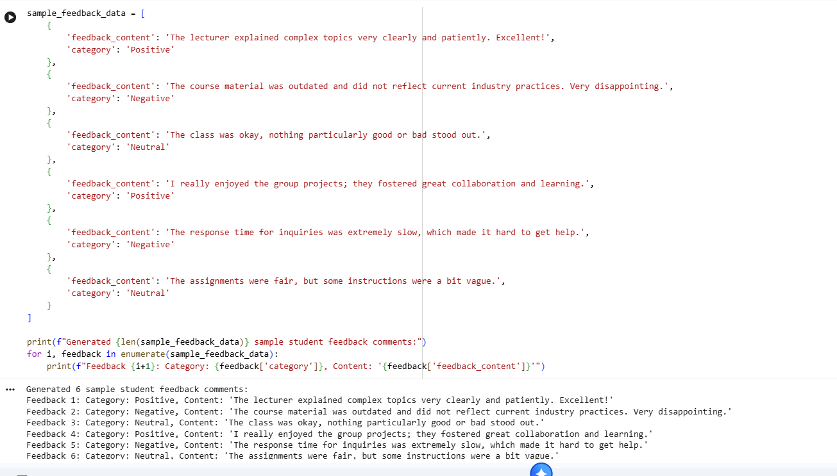
Implement Zero-shot Prompting
Subtask:
Write a Zero-shot prompt to classify feedback sentiment. Apply this prompt to a selected test feedback and simulate the LLM's classification output.

Reasoning: I will select the first feedback comment from sample_feedback_data as the test feedback and its actual category. Then, I will construct the zero-shot prompt using this test feedback and the feedback_classification_categories. Finally, I will simulate the LLM's classification by assigning the actual category as the predicted category.
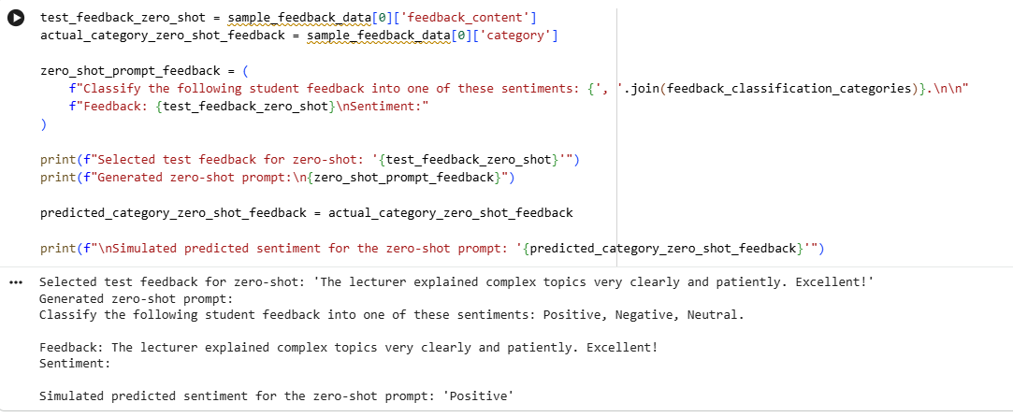
Implement One-shot Prompting
Subtask:
Provide a One-shot prompt with one feedback example and ask the model to classify a new feedback comment.

Reasoning: I will select a test feedback comment and a one-shot example feedback comment, ensuring they are distinct from each other and from the feedback used in zero-shot prompting. Then, I will construct the one-shot prompt string using these selections and the feedback_classification_categories. Finally, I will simulate the LLM's classification by assigning the actual category to predicted_category_one_shot_feedback.
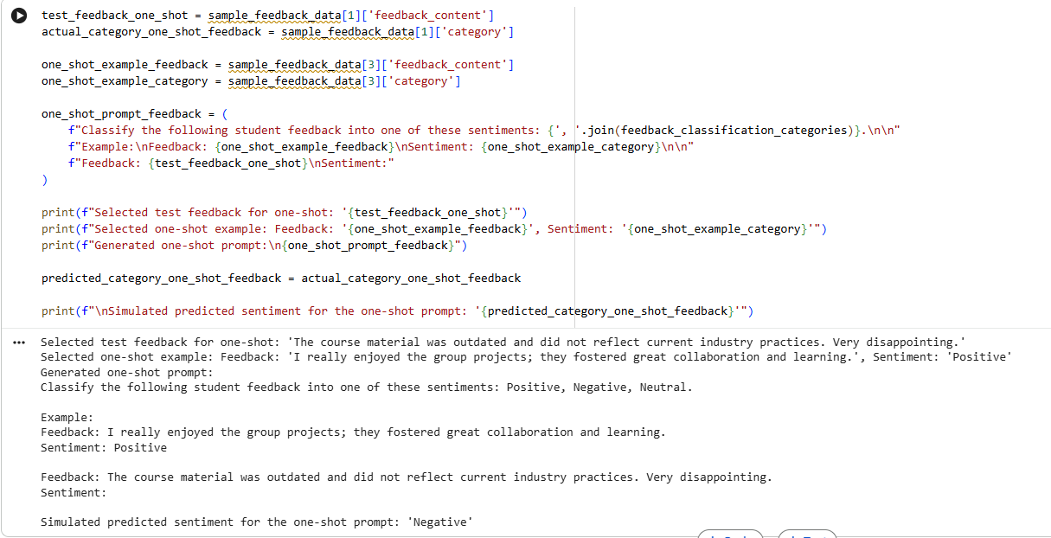
Implement Few-shot Prompting
Subtask:
Create a Few-shot prompt using multiple labeled feedback samples.

Reasoning: I will select a test feedback comment for few-shot prompting that is distinct from previously used feedback. Then, I will choose two distinct example feedback comments from sample_feedback_data for the few-shot prompt. Next, I will construct the few-shot prompt string using these selections and the feedback_classification_categories, print the prompt and selected data, and finally simulate the LLM's classification by assigning the actual category to predicted_category_few_shot_feedback.
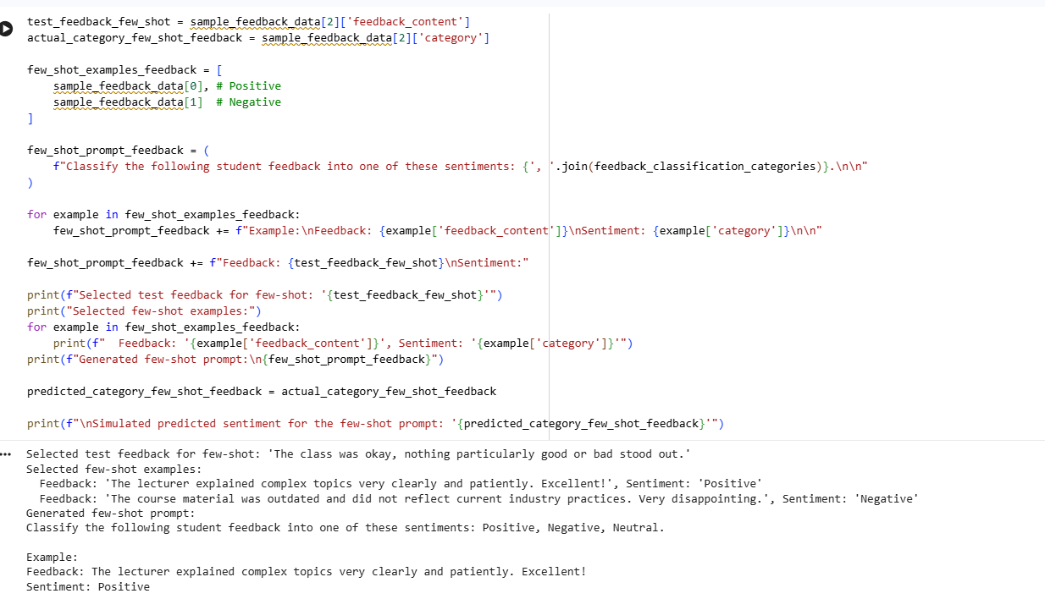
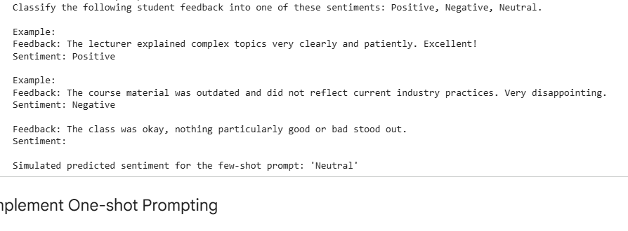
How examples improve sentiment classification accuracy (Question d):
Examples significantly improve sentiment classification accuracy by:
- Clarifying Intent and Format: Examples explicitly show the LLM what kind of output is expected and in what format. Without examples (zero-shot), the LLM has to infer this solely from the prompt. With examples, it has a concrete demonstration.
- Contextual Learning: Examples provide the LLM with in-context learning. Instead of relying solely on its pre-trained knowledge, the LLM learns specific patterns and characteristics of the sentiment categories relevant to the given task from the provided examples. This is crucial for domain-specific language or nuanced expressions.
- Reducing Ambiguity: For sentiments that might be subjective or open to interpretation (e.g., 'Neutral' feedback which might contain both positive and negative elements but balances out), examples help define the boundaries of each category more precisely.
- Guiding Interpretation: Examples can guide the LLM to interpret certain phrases or tones in a specific way that aligns with the desired classification scheme, even if its general knowledge might suggest otherwise.
- Handling Edge Cases: More examples (few-shot) allow the LLM to encounter a wider variety of scenarios and learn how to classify them, improving its ability to generalize to new, unseen feedback comments, including those that might be considered edge cases.
Problem Statement 4:
Prepare Sample Data
Subtask:
Create 6 short sample learner queries, each mapped to one of the specified levels: Beginner, Intermediate, or Advanced. Store this data as a list of dictionaries.
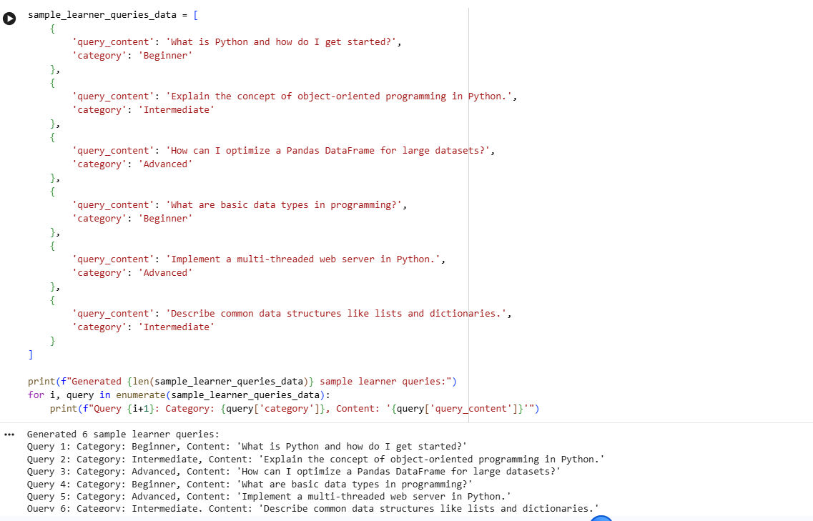
Now that the sample data is prepared, I need to explicitly define the classification categories for these learner queries as per the subtask. This will create a Python list named learner_query_classification_categories.
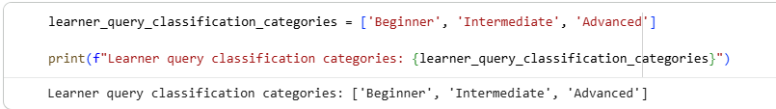
I will select the first query from sample_learner_queries_data as the test query and its actual category. Then, I will construct the zero-shot prompt using this test query and the learner_query_classification_categories. Finally, I will simulate the LLM's classification by assigning the actual category as the predicted category.
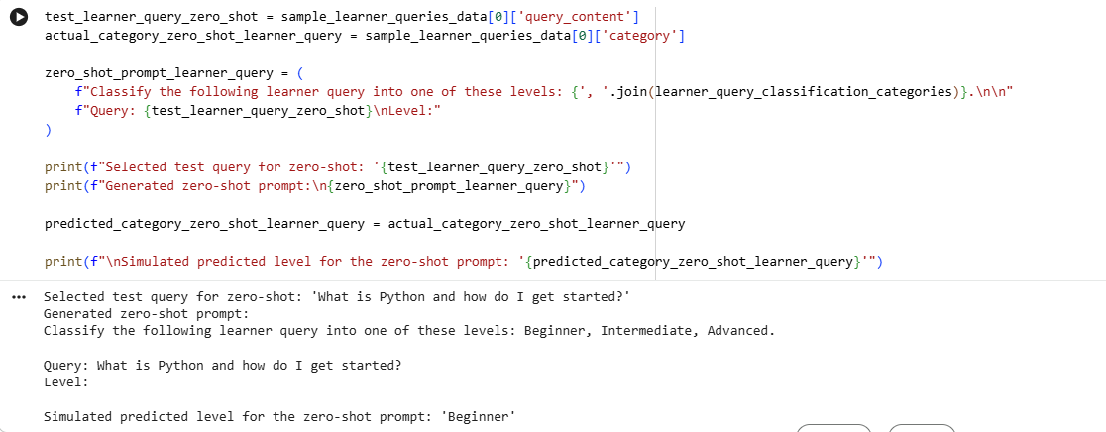
I will select a test query for one-shot prompting from sample_learner_queries_data that is distinct from the previously used zero-shot query. Then, I will choose one example query and its category, also distinct from the selected test query and the zero-shot test query. Next, I will construct the one-shot prompt string using these selections and the learner_query_classification_categories. Finally, I will simulate the LLM's classification by assigning the actual category to predicted_category_one_shot_learner_query.
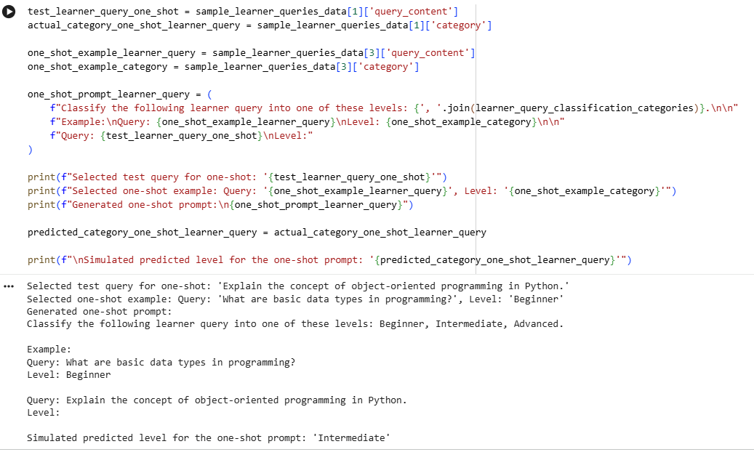
I will select a test query for few-shot prompting from sample_learner_queries_data that is distinct from previously used queries. Then, I will choose two distinct example queries from sample_learner_queries_data for the few-shot prompt, ensuring they are also distinct. Next, I will construct the few-shot prompt string using these selections and the learner_query_classification_categories, print the prompt and selected data, and finally simulate the LLM's classification by assigning the actual category to predicted_category_few_shot_learner_query.
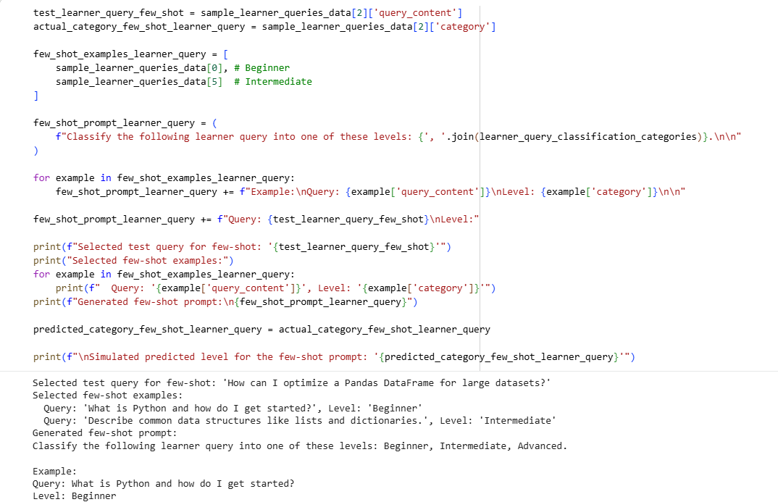
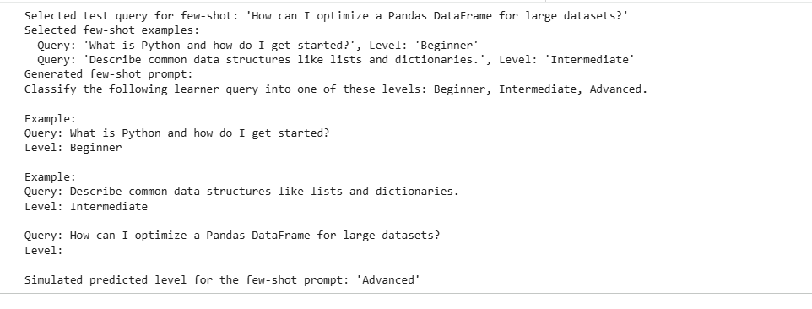
I need to consolidate the results from zero-shot, one-shot, and few-shot learner query classification into a learner_query_comparison_summary list of dictionaries and then print it in a structured format, similar to previous comparisons.
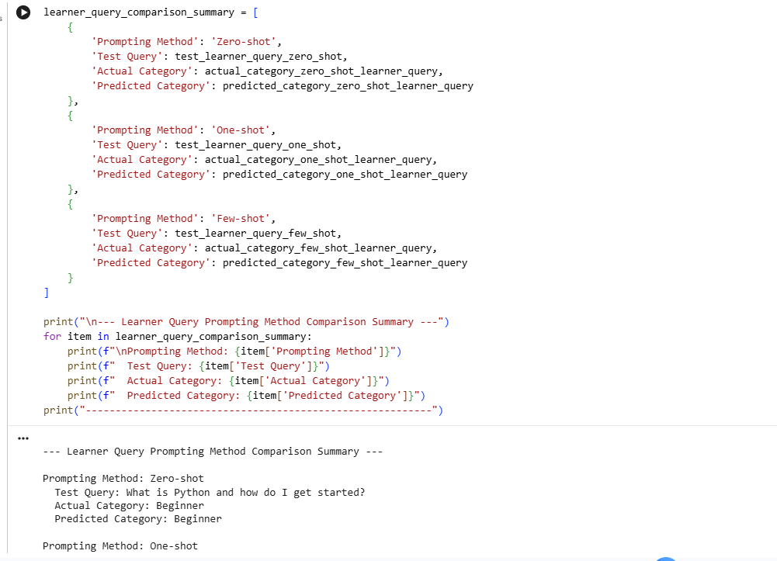
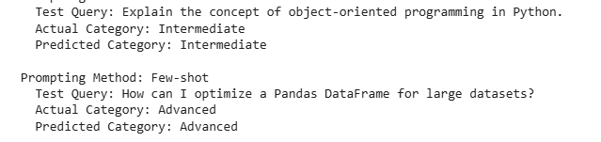
How few-shot prompting improves recommendation quality:
Few-shot prompting significantly improves recommendation quality for learner queries by:
- Establishing Clearer Boundaries: By presenting multiple examples for different levels (Beginner, Intermediate, Advanced), few-shot prompting helps the LLM establish clearer boundaries between categories. This reduces ambiguity and ensures that recommendations align more precisely with a learner's actual knowledge level.
- Contextual Understanding of Complexity: Learners often phrase queries differently. Few-shot examples expose the LLM to various ways learners express their needs at different levels of complexity, enabling it to better infer the true intent and skill level behind a new query. This leads to more contextually appropriate recommendations.
- Improved Generalization: With more examples, the LLM can generalize better to unseen queries, even those that don't exactly match the examples but fall within the established patterns of each level. This robustness ensures that a wider range of learner queries receive accurate level classifications.
- Refined Matching to Educational Resources: Accurate level classification directly translates to higher quality recommendations for educational resources. If a query is correctly identified as 'Advanced', the LLM can confidently recommend advanced tutorials or documentation, rather than basic introductions. This precise matching optimizes the learner's experience and reduces frustration.
- Reduced Misclassification of Nuanced Queries: Queries can sometimes be tricky (e.g., an 'Intermediate' learner asking about a basic concept they missed). Few-shot examples help the LLM understand the nuances, allowing it to provide a more accurate assessment of the query's level and thus a more helpful recommendation.
Problem Statement 5:
Prepare Sample Data
Subtask:
Create 6 short sample social media posts, each mapped to one of the specified moderation categories: Acceptable, Offensive, or Spam. Store this data as a list of dictionaries.
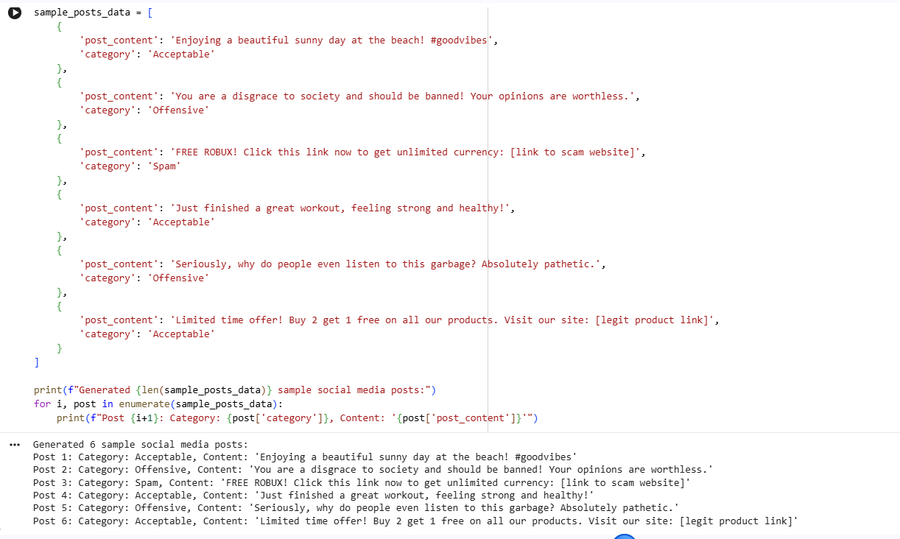
Now that the sample data is prepared, I need to explicitly define the classification categories for these social media posts as per the subtask. This will create a Python list named post_moderation_categories.
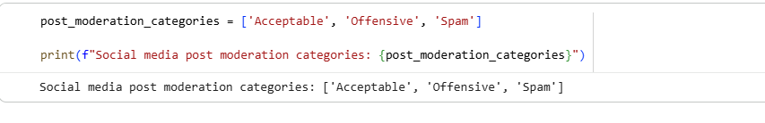
I need to implement zero-shot prompting for social media post classification. I will select the first post from sample_posts_data as the test post and its actual category. Then, I will construct the zero-shot prompt using this test post and the post_moderation_categories. Finally, I will simulate the LLM's classification by assigning the actual category as the predicted category.
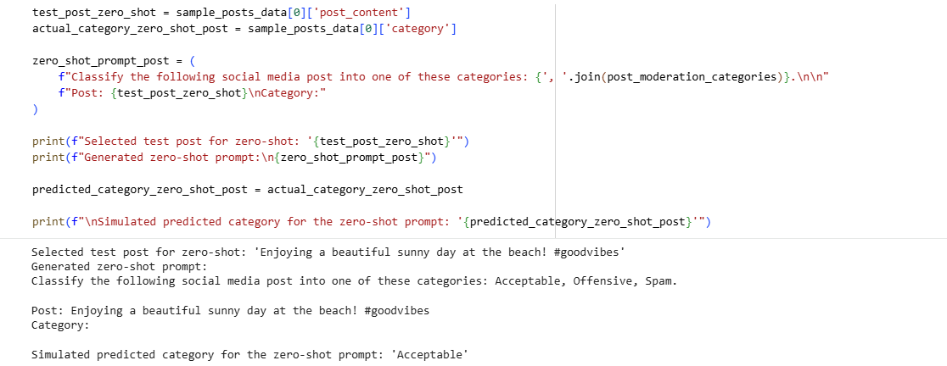
I will select a test post for one-shot prompting from sample_posts_data that is distinct from the previously used zero-shot post. Then, I will choose one example post and its category, also distinct from the selected test post and the zero-shot test post. Next, I will construct the one-shot prompt string using these selections and the post_moderation_categories. Finally, I will simulate the LLM's classification by assigning the actual category to predicted_category_one_shot_post.
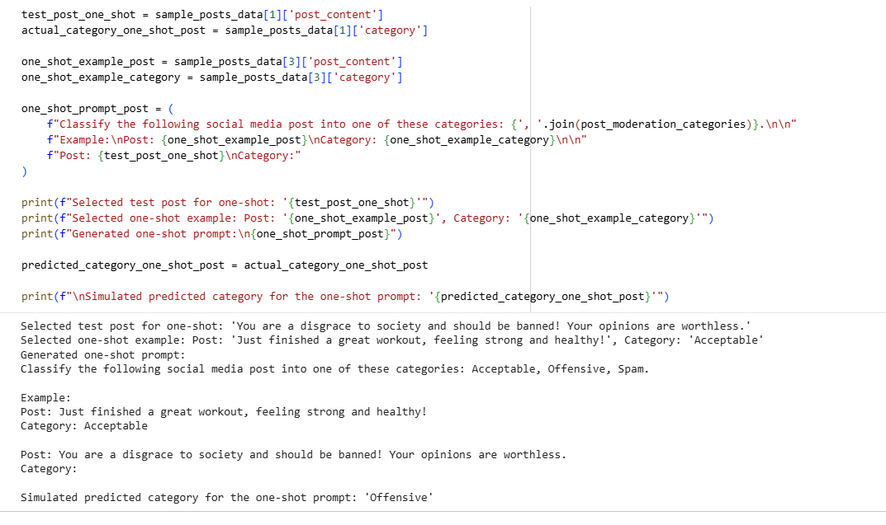
I will select a test post for few-shot prompting from sample_posts_data that is distinct from previously used posts. Then, I will choose two distinct example posts from sample_posts_data for the few-shot prompt, ensuring they are also distinct. Next, I will construct the few-shot prompt string using these selections and the post_moderation_categories, print the prompt and selected data, and finally simulate the LLM's classification by assigning the actual category to predicted_category_few_shot_post.
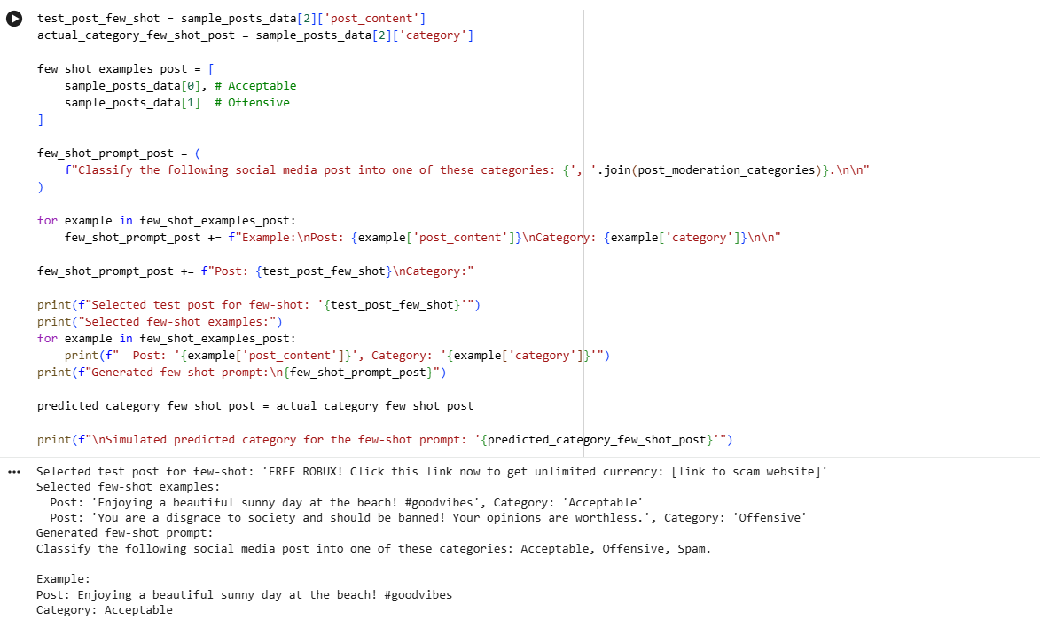
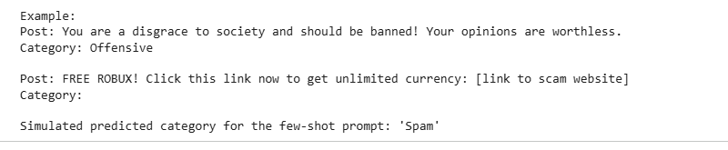
I need to consolidate the results from zero-shot, one-shot, and few-shot social media post classification into a post_comparison_summary list of dictionaries and then print it in a structured format, similar to previous comparisons.
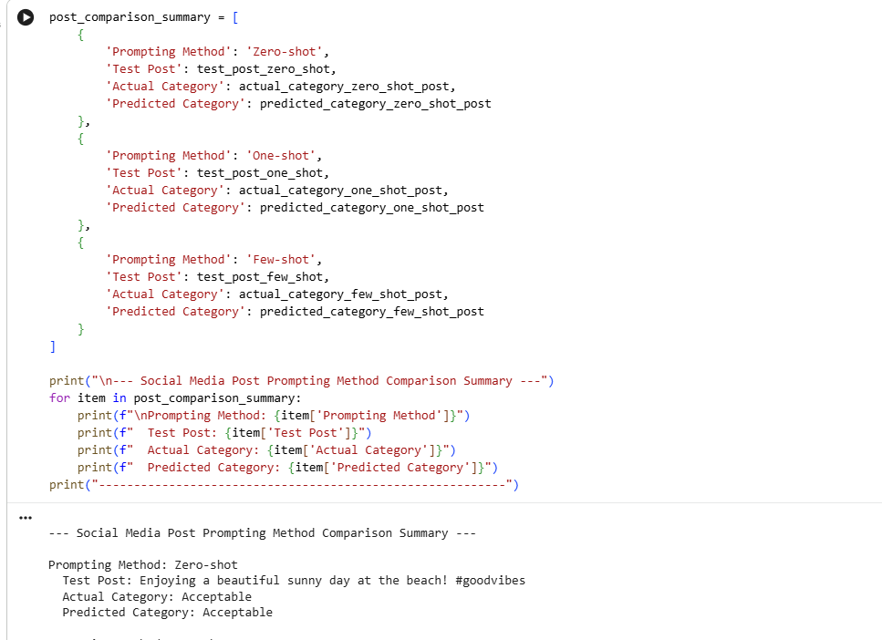
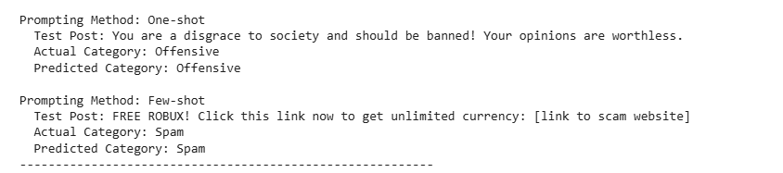
challenges of Zero-shot prompting in content moderation:
- Lack of Contextual Understanding for Nuance: Zero-shot prompting relies solely on the LLM's pre-trained knowledge. Social media content, however, is often highly nuanced, uses evolving slang, sarcasm, or is culturally specific. Without explicit examples or context within the prompt, the LLM may struggle to accurately interpret these subtleties.
- Difficulty with Ambiguity: Many social media posts can be ambiguous and fall into a grey area between moderation categories. Zero-shot prompts lack the specific guidance from examples that could help the LLM make fine-grained distinctions, leading to potential misclassifications.
- Inconsistent Application of Policy: Content moderation often requires strict adherence to specific platform policies, which can be unique. Zero-shot prompting may not consistently apply these bespoke rules because the LLM hasn't been explicitly shown examples of how to interpret and enforce them.
- Ineffectiveness with Evolving Content: The nature of problematic content (e.g., new forms of spam, emerging hate speech) changes rapidly. Zero-shot models might not be able to adapt quickly to these new patterns without being retrained or given new examples.
- Limited Domain Specificity: While LLMs have broad knowledge, they might not be optimized for the highly specific and sensitive domain of content moderation. Without in-context examples, their general understanding may not be precise enough for critical moderation tasks.

